Setting up Permissions
Open Server Manager, expand Roles, expand Active Directory Users and scroll down to New and click on “Organizational Unit”.
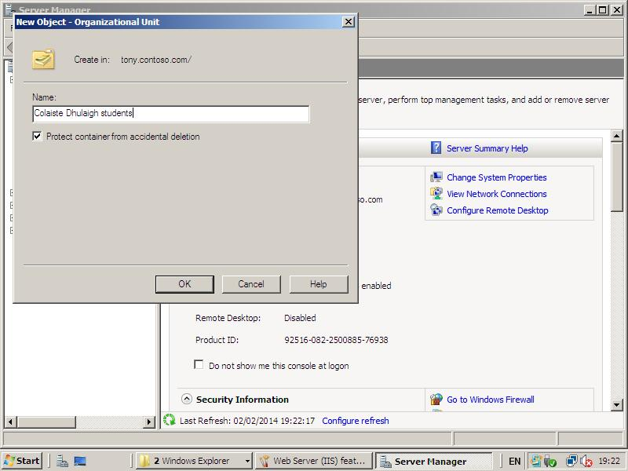 | Type in name “Whatever” and click okay.  Open “contoso.com” and select your new Org. Unit. (Colaiste Dhulaigh)

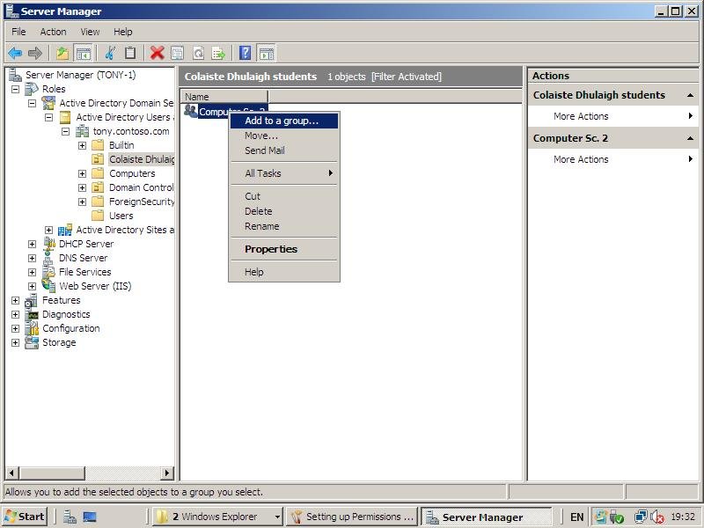 | Set up group – Computer Sc. 2 in Colaiste Dhulaigh folder.  Double click on Computer Sc. 2 and select members, then “Add” and enter previously entered objects in “Users”.

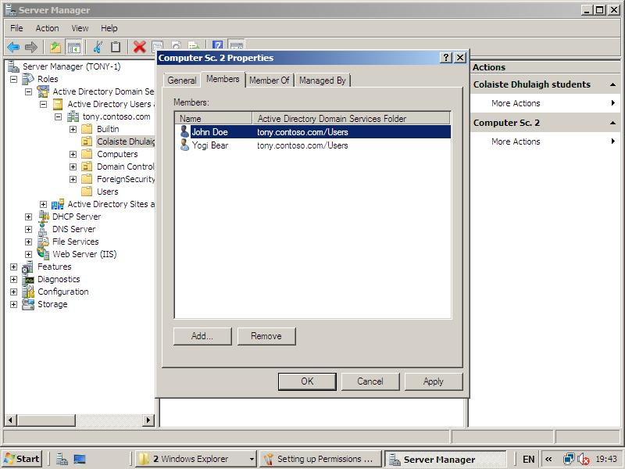

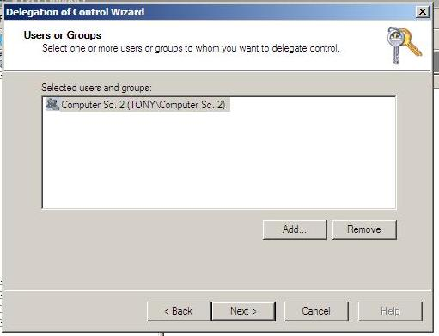 | Right click on “Colaiste Dhulaigh” and select “Delegate Control” and the Wizard opens up.

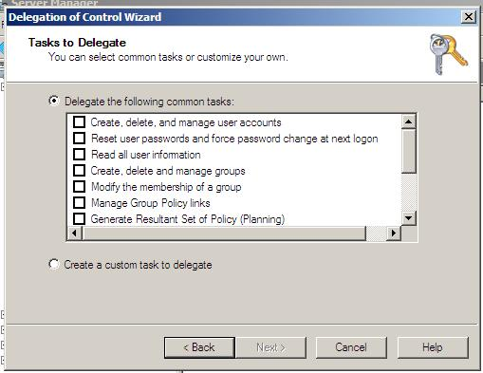 | In the “Tasks to Delegate” window select any of the common tasks or create a custom task to delegate.

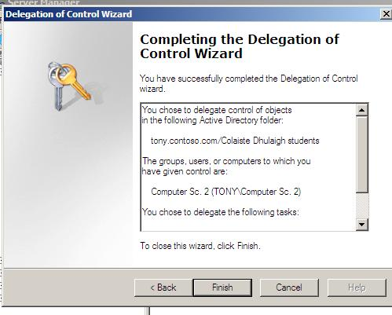 | Click next and in next window “Finish”.  If delegating control to a single user, in Server Manager in the tools bar, select “Action” and from the drop down list select “Delegate Control”.

